EXPERIMENT 13:
You are tasked with developing an Online Learning Platform. The platform should include the following functionalities:
  - Course Enrollment and Registration
  - Video Lecture Streaming
  - Interactive Quizzes and Assignments
  - Progress Tracking Dashboard
  - Peer-to-Peer Discussion Forums
  - Certificate Generation
Use Jira to categorize and prioritize these requirements using MoSCoW and Kano techniques.
Step 1: Login
- Open a web browser and navigate to the Jira website.
- Login - https://id.atlassian.com/login
- Sign in to your Jira account using your registered email address and password.
Step 2: Create a New Project
- Click Create Project.
- Select Scrum
- Enter the project name as Task Management System.
- Choose Team-managed.
- Click Create.
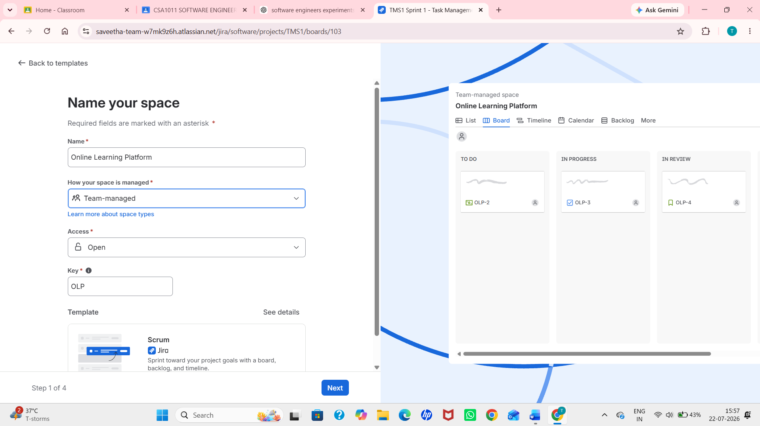
Step 3: Open the Backlog
- Select the Online Learning Platform project.
- Click the Backlog tab.
- Create a new sprint if one is not already available.
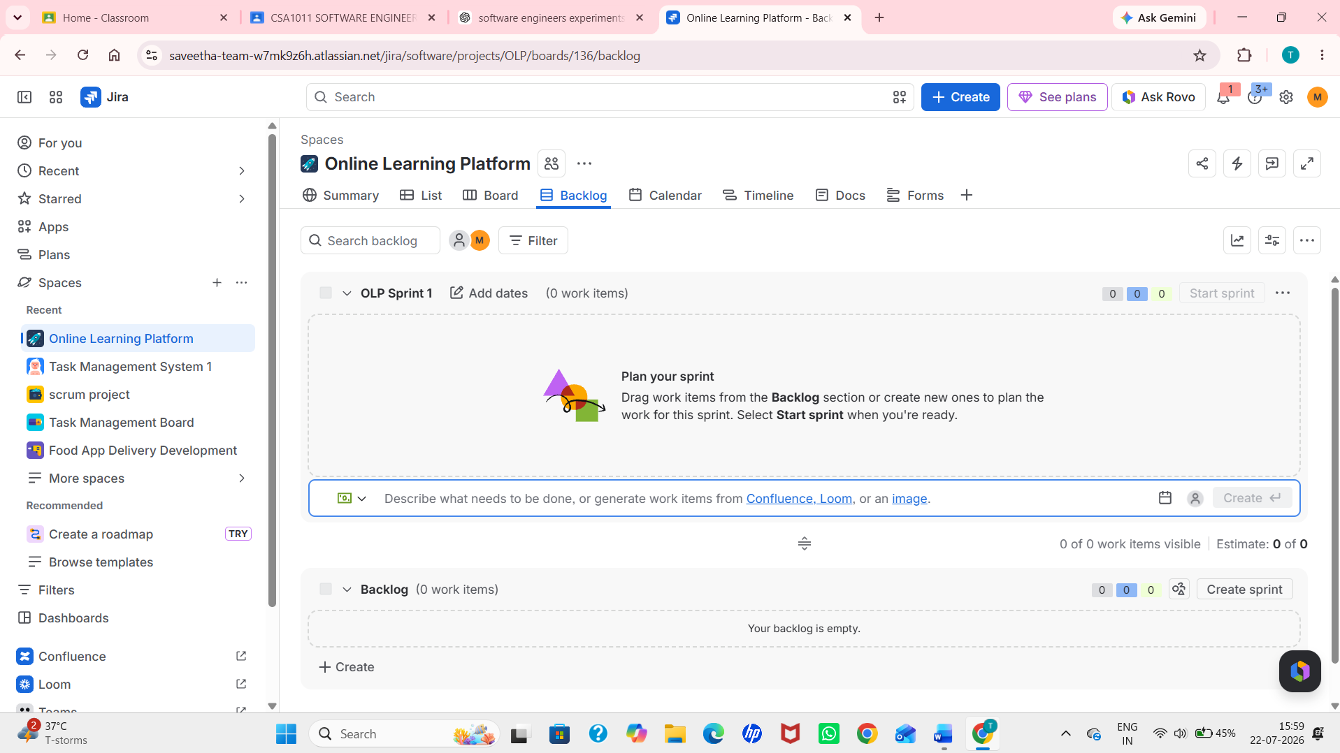
Step 4: Create the Project Requirements as Tasks
Create the following six tasks:
- Course Enrollment and Registration
- Video Lecture Streaming
- Interactive Quizzes and Assignments
- Progress Tracking Dashboard
- Peer-to-Peer Discussion Forums
- Certificate Generation
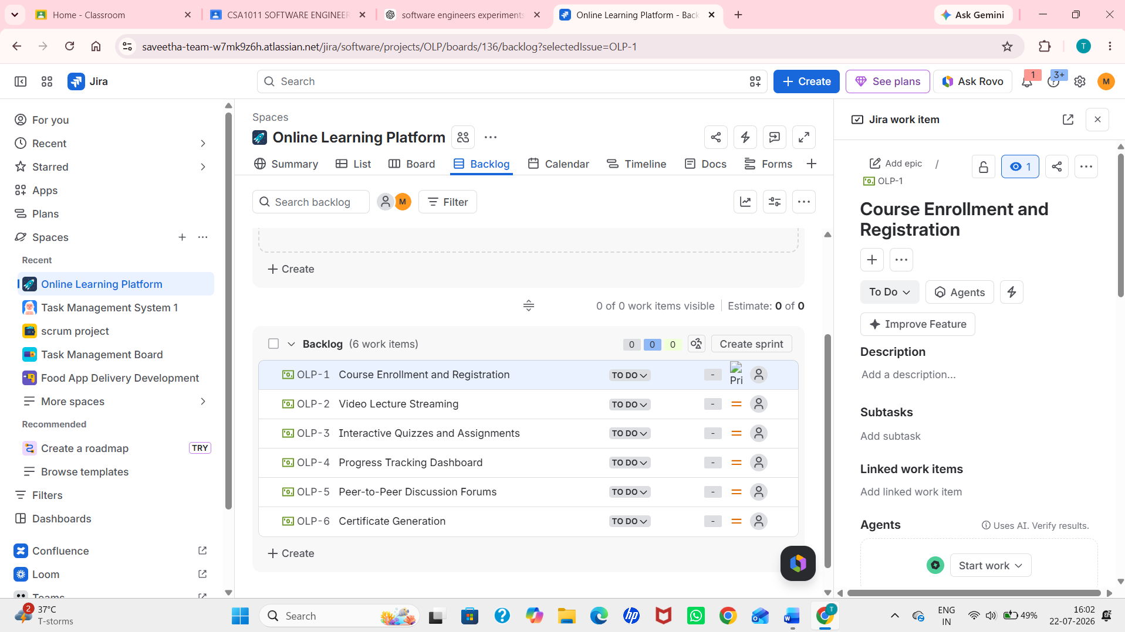
Step 5: Add Tasks to the Sprint
- Drag all six tasks into Sprint 1.
- Verify that all tasks are added to the sprint.
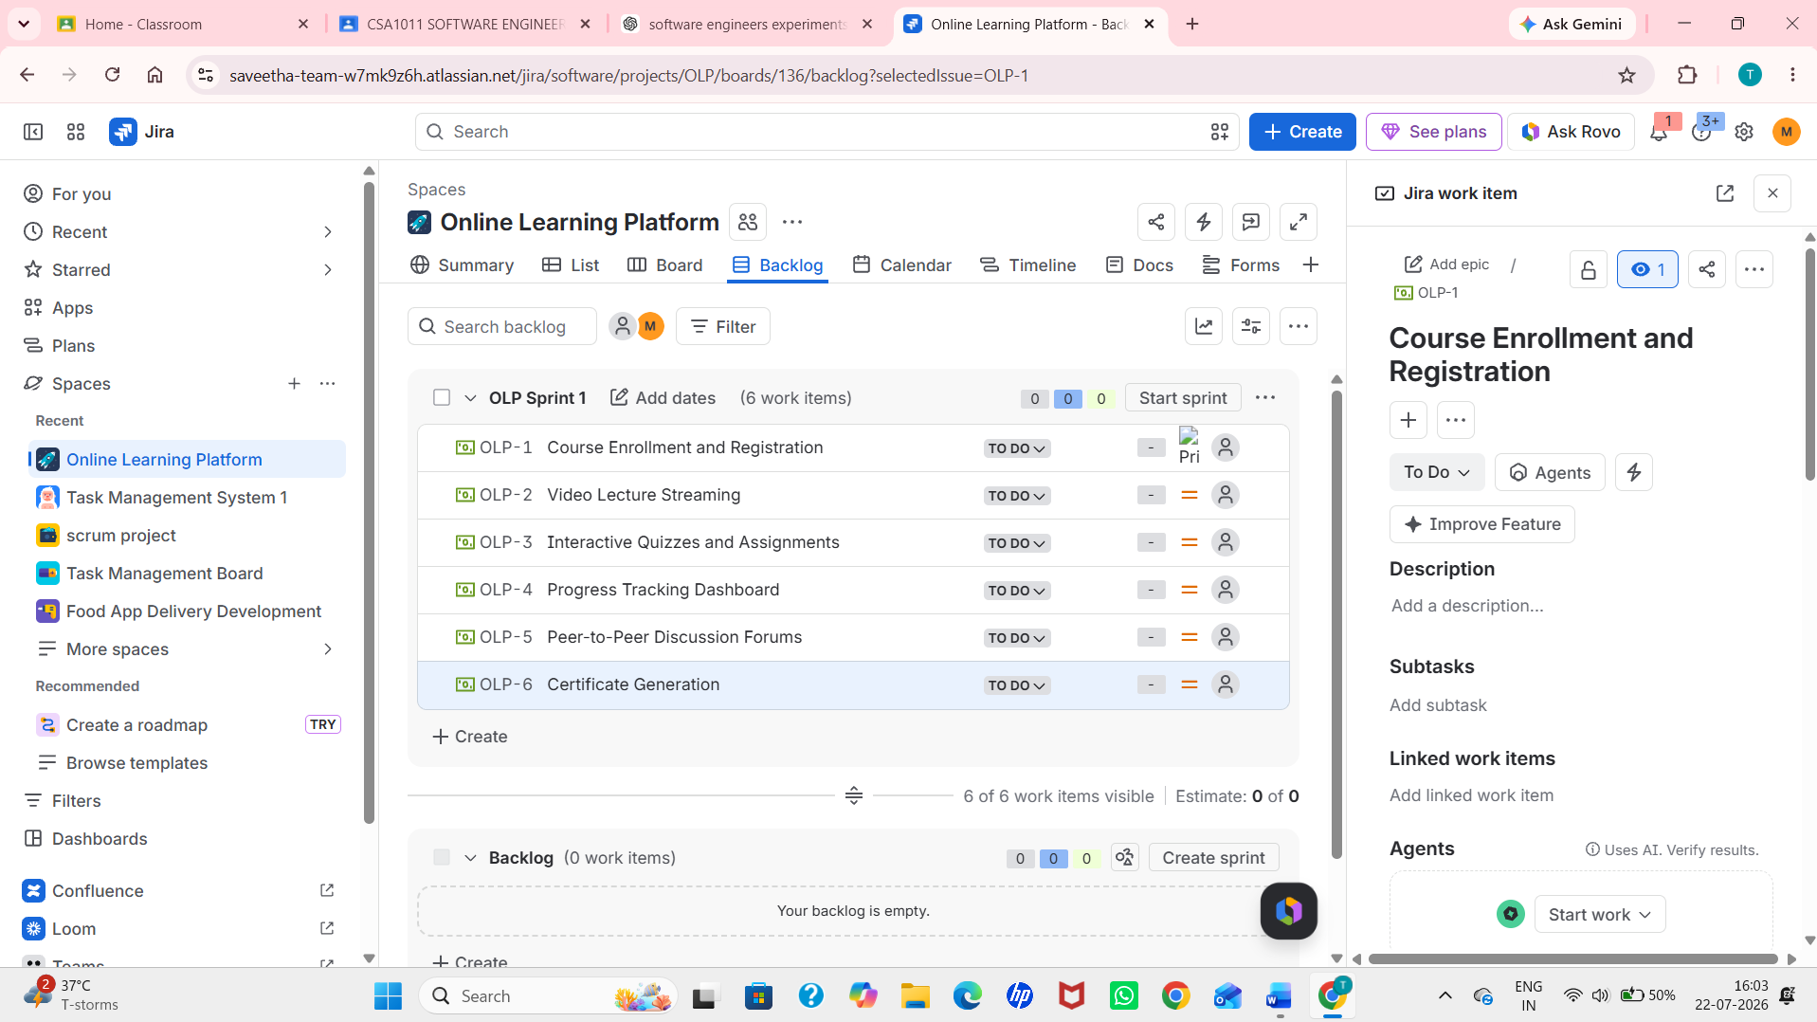

Step 6: Start the Sprint
- Click Start Sprint.
- Set the sprint duration to 1 Week.
- Click Start.
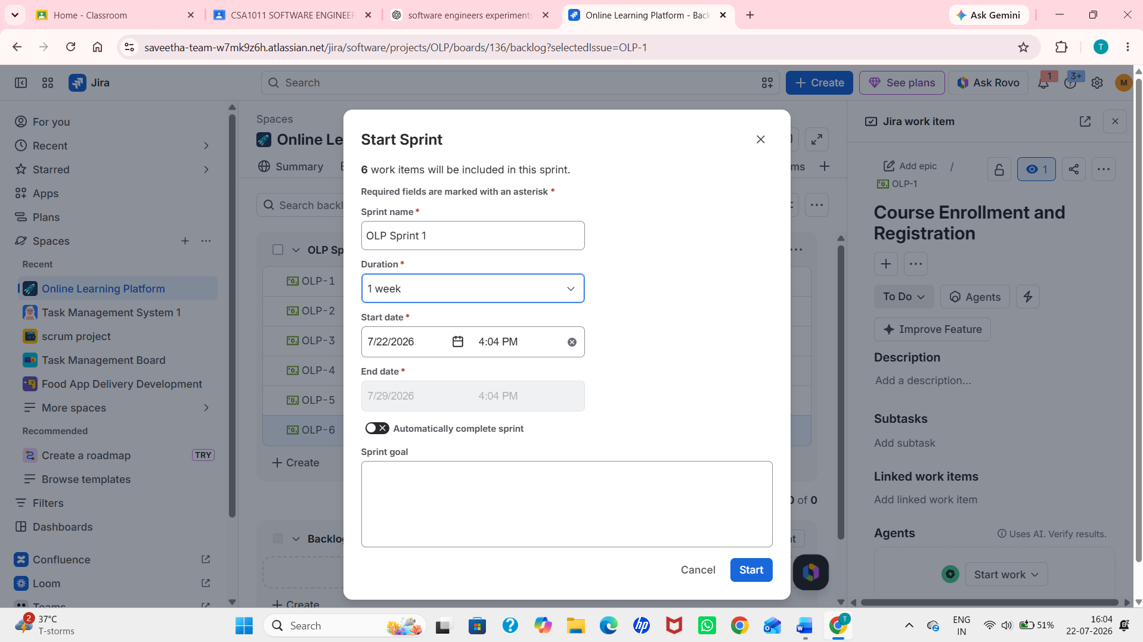
Step 7: Categorize Requirements Using the Kano Model
Add another label to each task based on the Kano model.
Requirement | Kano
Course Enrollment and Registration | Basic
Video Lecture Streaming | Performance
Interactive Quizzes and Assignments | Performance
Progress Tracking Dashboard | Performance
Peer-to-Peer Discussion Forums | Excitement
Certificate Generation | Excitement
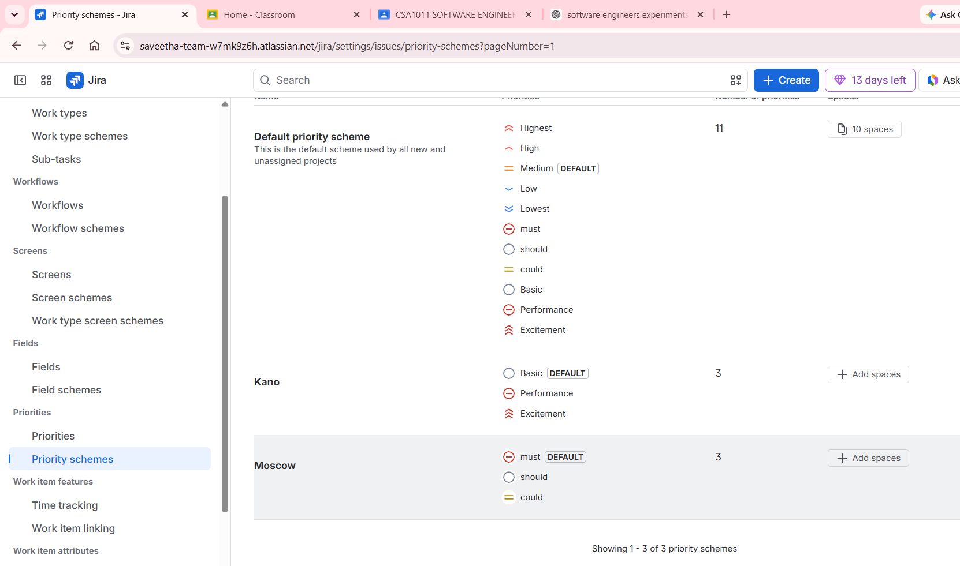
Step 9: Verify the Prioritization
- Open each task and verify that both the Kano labels are correctly assigned.
- Ensure all six tasks are displayed in the Sprint Board.
